Resistive Transducer

* A resistive transducer is an electronic device that is capable of measuring various physical quantities like temperature, pressure, vibration, force, etc. These physical quantities are otherwise extremely difficult to measure as they can change easily. However, using this transducer, you can easily calculate the values of these quantities.
* These transducers can function in both primary as well as in secondary mode but most of the time it is used as secondary. This is because the output of the primary transducer can be given as an input to this transducer.

Potentiometric Tranducer:

* A potentiometric transducer(resistive-type [transducer](https://www.sciencedirect.com/topics/engineering/transducers) ) is an electromechanical device. It is a passive transducer. It requires external power source for its functioning.
* It converts either linear or angular displacement into an output voltage by moving a sliding contact along the surface of a [resistive element](https://www.sciencedirect.com/topics/engineering/resistive-element) with the help of wiper. The motion of the wiper may be translatory or rotational.
* A voltage, Vi, is applied across the [resistor](https://www.sciencedirect.com/topics/engineering/resistor), R. The output voltage, Vo, between the sliding contact and one terminal of the resistor is linearly proportional to the displacement. Typically, a [constant current source](https://www.sciencedirect.com/topics/engineering/constant-current-source) is passed through the variable resistor, and the small change in output voltage is measured by a sensitive voltmeter using [Ohm's law](https://www.sciencedirect.com/topics/engineering/ohms-law) (i.e., I = V/R).

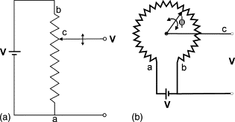

  Inductive Transducer

A transducer that works on the principle of electromagnetic induction or transduction mechanism is called an inductive transducer. A self-inductance or mutual inductance is varied to measure required physical quantities like displacement (rotary or linear), force, pressure, velocity, torque, acceleration, etc. These physical quantities are noted as measurands. [Linear Variable Differential Transformer (LVDT)](https://www.watelectronics.com/lvdt-linear-variable-displacement-transformer/) is an example of an inductive transducer.

### Types of the Inductive Transducer:

#### 1 - Simple Inductance Type:

In this type of transducer, a single coil is used to measure the required parameter. The change in displacement changes the permeability of the flux produced in the circuit results in a change in the inductance of the coil and the output.

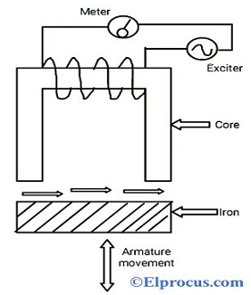

#### 2 - Mutual Inductance Transducers (two coils):

In this type, two coils are used for mutual induction. One for generating excitation and another for output. The voltage difference between the two coils depends on the movement of the armature. This type is also called a differential mutual inductive transducer.

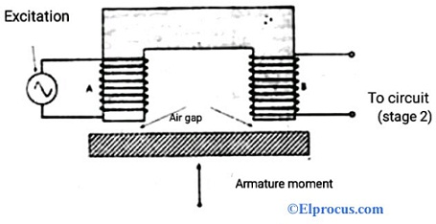

### Working Principle:

Change in Self-inductance

Consider the self-inductance of the coil be,

**L = N2/R**

The expression for the reluctance of the coil is,

**R = l/µA**

L = **N2µA/l**

**L = N2µG**

Where ‘N’ represents no.of turns

‘R’ represents the magnetic circuit’s reluctance

‘μ’ represents permeability of the coil (medium in and around the coil)

G= A/l = geometric form factor

‘A’ represents a cross-section area of the coil

‘l’ represents the length of the coil

From the above equations, we can observe that self-inductance can be varied or changed by changing the no.of turns, or geometric form factor or permeability of the coil.

### Change in Mutual Inductance

Inductive transducers also on the principle of mutual inductance of multiple coils.

We consider the two coils, which have self-inductance L1 and L2

The mutual inductance of the coils is given by,

**M = K √L1L2**

Where ‘K’ represents the coefficient of coupling

## What is a photoelectric transducer?

## This transducer type has been designed to convert light energy into electrical energy. Photoelectric transducers are made from semiconductor materials. They use a photosensitive element that is capable of ejecting electrons. This process happens when the photoelectric transducer absorbs a beam of light that shines on the semiconductor material.

## Photoelectric Transducer

**Different photoelectric transducer types**

Transducers have different types, each suitable for specific applications. They include:

* **PhotoJunction**
* **PhotoConductive Cell**
* **Photovoltaic Cell**
* **PhotoEmissive Cell or Tubes**

# Photovoltaic Cell :

A photovoltaic (PV) cell, also known as a solar cell, is an electronic component that generates electricity when exposed to photons, or particles of light. This conversion is called the photovoltaic effect.

It is based on the theory ‘Photoelectric effect’ given by **Albert Einstein .**

A photovoltaic cell is made of semiconductor materials that absorb the photons emitted by the sun and generate a flow of electrons.

## Construction of Solar Cell :

## A very thin layer of [p-type semiconductor](https://www.electrical4u.com/p-type-semiconductor/) is grown on a relatively thicker [n-type semiconductor](https://www.electrical4u.com/n-type-semiconductor/). We then apply a few finer [electrodes](https://www.electrical4u.com/surface-electrodes/) on the top of the p-type semiconductor layer.

## solar cell

## Working Principle of Solar Cell

When light reaches the [p-n junction](https://www.electrical4u.com/p-n-junction-theory-behind-p-n-junction/), the light photons can easily enter in the junction, through very thin p-type layer. The light energy, in the form of photons, supplies sufficient energy to the junction to create a number of electron-hole pairs. The incident light breaks the thermal equilibrium condition of the junction. The free electrons in the depletion region can quickly come to the n-type side of the junction.

Similarly, the holes in the depletion can quickly come to the p-type side of the junction. Once, the newly created free electrons come to the n-type side, cannot further cross the junction because of barrier potential of the junction.

### 